**FeedChain – Smart Donation And Leftover Food Mapper**

**A SOCIALLY RELEVANT MINI PROJECT REPORT**

***Submitted by***

**GOWTHAMAN V P [211423104183] ENOCH JACKSON C [211423104153]**

***in partial fulfillment for the award of the degree of***

**BACHELOR OF ENGINEERING**

***in***

# COMPUTER SCIENCE AND ENGINEERING



**PANIMALAR ENGINEERING COLLEGE**

**(An Autonomous Institution, Affiliated to Anna University, Chennai)**

**October 2025**

**PANIMALAR ENGINEERING COLLEGE**

**(An Autonomous Institution, Affiliated to Anna University, Chennai)**

**BONAFIDE CERTIFICATE**

Certified that this project report **“FeedChain – Smart Donation And Leftover Food Mapper”** is the Bonafide work of **GOWTHAMAN V P [211423104183],** **ENOCH JACKSON C [211423104153],** who carried out the project work under my supervision.

**Signature of the HOD with date Signature of the Supervisor with date**

**Dr L.JABASHEELA M.E., Ph.D., Dr. P. DEEPA M.E., Ph.D.,**

Professor and Head,

Department of Computer Science and Engineering,

Panimalar Engineering College, Chennai- 600123

Associate Professor,

Department of Computer Science and

Engineering,

Panimalar Engineering College,

Chennai- 600123

Submitted for the 23CS1512 – Socially Relevant Mini Project Viva– Voce examination held on

**INTERNAL EXAMINER EXTERNAL EXAMINER**

**DECLARATION BY THE STUDENT**

We **“ GOWTHAMAN V P [211423104183], ENOCH JACKSON C [211423104153] ”** hereby declare that this project report titled **“FeedChain – Smart Donation And Leftover Food Mapper”** under the guidance of **Dr. P. DEEPA M.E., Ph.D.,** is the original work done by us and we have not plagiarized or submitted to any other degree in any university by us.

**GOWTHAMAN V P [211423104183]**

**ENOCH JACKSON C [211423104153]**

**ACKNOWLEDGEMENT**

We express our deep gratitude to our respected Secretary and Correspondent **Dr.P.CHINNADURAI, M.A., Ph.D.,** for his kind words and enthusiastic motivation, which inspired us a lot in completing this project.

We would like to extend our heartfelt and sincere thanks to our Directors

## Tmt.C.VIJAYARAJESWARI, Dr.C.SAKTHIKUMAR, M.E., Ph.D., and

**Dr. SARANYASREE SAKTHIKUMAR B.E.,M.B.A.,Ph.D.,** for providing us

with the necessary facilities for completion of this project.

Our gratitude is also extended to our Principal, **Dr. K. MANI, M.E., Ph.D.**, whose facilitation proved pivotal in the successful completion of this project.

We thank the HOD of CSE Department, **Dr.L.JABASHEELA M.E., Ph.D.,** for the support extended throughout the project.

We would like to thank our Project Guide and Project Coordinators **Dr. P. DEEPA M.E., Ph.D., Mrs. Lincy Jemina ,M.E.,(Ph.D)** and all the faculty members of the Department of CSE for their advice and suggestions for the successful completion of the project.

**GOWTHAMAN V P [211423104183]**

**ENOCH JACKSON C [211423104153]**

**ABSTRACT**

Food wastage and hunger continue to be two major global challenges that often coexist despite technological and economic progress. Every day, large quantities of edible food are discarded, while countless individuals remain food insecure. To address this imbalance, *FeedChain* has been developed as a Flutter-based mobile application that facilitates efficient food redistribution between donors and receivers in real time. The system serves as a bridge connecting people who have surplus food with those in need, fostering community collaboration to reduce waste and hunger.

The application is built using Flutter for a seamless cross-platform experience and integrated with Firebase for secure authentication, real-time cloud storage, and scalability. Users can register or log in, post available food donations, or raise requests for food assistance. The integration of Google Maps APIs enables geolocation tracking and visualization of donation and request points on an interactive map. This ensures that users can easily identify nearby food availability and navigate to the respective locations using the “Show Directions” feature.

FeedChain’s backend architecture leverages Cloud Firestore for managing dynamic user data and Firebase Authentication for secure access control. The use of Geolocator Services ensures accuracy in capturing user coordinates, while the intuitive interface allows easy interaction even for non-technical users. Donors can provide details such as food type, quantity, and expiry date, and receivers can view the listings in real time, ensuring transparency and quick communication.

By integrating modern cloud and mapping technologies, FeedChain contributes toward the United Nations Sustainable Development Goal (SDG) 2 – Zero Hunger by promoting food equity and sustainability. The system’s modular architecture allows for future enhancements such as AI-based matching, donation analytics, and NGO partnerships. Ultimately, FeedChain aims to reduce food wastage, streamline redistribution efforts, and create a socially responsible ecosystem where technology serves humanity for a greater cause.

**TABLE OF CONTENTS**

|  |  |  |
| --- | --- | --- |
| **CHAPTER**  **NO** | **TITLE** | **PAGE NO.** |
|  | **ABSTRACT** | v |
|  | **LIST OF TABLES** | viii |
|  | **LIST OF FIGURES** | ix |
| **1.** | **INTRODUCTION** | **1** |
|  | 1.1 Overview | 1 |
|  | 1.2 Problem Definition | 2 |
|  | 1.3 Literature Review | 3 |
| **2.** | **SYSTEM ANALYSIS** | **5** |
|  | 2.1 Existing System | 5 |
|  | 2.2 Proposed System | 5 |
|  | 2.3 Implementation Environment | 7 |
| **3.** | **SYSTEM DESIGN** | **8** |
|  | 3.1 UML Diagrams | 8 |
| **4.** | **SYSTEM ARCHITECTURE** | **15** |
|  | 4.1 Architecture Diagram | 15 |
|  | 4.2 Module Description | 17 |
| **5.** | **SYSTEM IMPLEMENTATION** | **20** |
|  | 5.1 Sample Coding | 20 |

|  |  |  |
| --- | --- | --- |
| **6.** | **PERFORMANCE EVALUATION** | **24** |
|  | 6.1 Performance Parameters | 24 |
|  | 6.2 Results and Discussion | 25 |
| **7.** | **CONCLUSION AND FUTURE WORK** | **26** |
|  | 7.1 Conclusion | 26 |
|  | 7.2 Future Enhancement | 27 |
|  | **APPENDICES** | **28** |
|  | A.1 SDG goals | 28 |
|  | A.2 Screenshots | 29 |
|  | A.3 Paper Publication | 37 |
|  | A.4 Plagiarism report | 42 |
|  | **REFERENCES** | **43** |

**LIST OF TABLES**

|  |  |  |
| --- | --- | --- |
| **TABLE NO.** | **TABLE DESCRIPTION** | **PAGE NO** |
| 4.1. | Initial input values for Match Engine | 17 |
| 4.2. | Final Match Score Values | 18 |
| 6.1 | System Parameters | 24 |
| A.1 | Mapped SDG Goals | 28 |

**LIST OF FIGURES**

|  |  |  |
| --- | --- | --- |
| **FIG NO.** | **FIGURE DESCRIPTION** | **PAGE NO** |
| 3.1. | Use-Case diagram of FeedChain’s System | 8 |
| 3.2. | Activity diagram of FeedChain | 9 |
| 3.3. | Class diagram of FeedChain | 10 |
| 3.4. | Sequence diagram of FeedChain | 11 |
| 3.5. | Deployment diagram of FeedChain | 14 |
| 4.1. | System Architecture of FeedChain | 15 |
| A.1. | Screenshot of user data stored in firebase authentication | 29 |
| A.2. | Screenshot of donations and request stored in firestore database | 29 |
| A.3. | Screenshot of entering login details | 30 |
| A.4. | Screenshot of donations pinned in the donations page | 31 |
| A.5. | Screenshot of the requests pinned in the requests page | 32 |
| A.6. | Input data in the donations form to post a donation | 33 |
| A.7. | Input data in the requests form to post a request | 34 |
| A.8. | Screenshot of a donation | 35 |
| A.9. | Screenshot of a request post | 36 |

**CHAPTER 1**

**INTRODUCTION**

* 1. **OVERVIEW**

Food wastage remains one of the most pressing global issues of our time. Each year, millions of tons of food are wasted while millions of people still struggle to obtain a single nutritious meal. In a developing country like India, this contrast between abundance and scarcity is particularly stark. Events, restaurants, and households often dispose of surplus food that could otherwise feed the underprivileged. The lack of a systematic mechanism for food redistribution leads to inefficiency, waste, and environmental harm.

To address this challenge, *FeedChain* has been developed as a technology-driven solution that connects food donors and receivers through a seamless, real-time mobile platform. FeedChain leverages Flutter for cross-platform app development, Firebase for backend data management, and Google Maps API for precise geolocation tracking. Donors can upload food availability details, while receivers can locate and request donations nearby. The platform provides live map visualization, easy authentication, and data security through Firebase Authentication and Firestore.

FeedChain contributes directly to the United Nations Sustainable Development Goal (SDG) 2 – Zero Hunger, by promoting equitable food access and encouraging social responsibility. The system’s core design philosophy is simplicity, inclusivity, and transparency. Whether it is an NGO coordinating relief efforts or an individual household donating leftovers, FeedChain ensures that surplus food reaches those who need it before it spoils.

**1.2 PROBLEM DEFINITION**

Despite the presence of charitable organizations and food banks, the redistribution of excess food remains inefficient due to several operational and communication gaps. Most food donation activities still depend on manual coordination—via phone calls, social media, or word of mouth—which are unreliable and time-consuming. In such cases, there is no centralized platform to connect donors and recipients instantly or to track the location and quality of donations.

FeedChain aims to solve this problem by introducing a cloud-based, location-aware mobile application that automates the donation process. The system allows donors to upload surplus food details along with their real-time location, and receivers can identify available food nearby through an interactive map. Using Firebase Cloud Firestore, every donation or request is stored in real-time, ensuring accessibility from anywhere. The app also maintains user authentication and identity security.

The key problem addressed by FeedChain is the lack of real-time communication and visibility between food donors and recipients. By integrating modern technologies, it minimizes time delays, prevents food spoilage, and encourages wider participation in community welfare.

**1.3 LITERATURE REVIEW**

Prova et al. [1] developed a Smart Food Rescue System integrating machine learning and cloud technology to automate surplus food tracking and redistribution. Their work demonstrated that cloud-based integration significantly enhances coordination between donors and NGOs; however, the system lacked real-time user interaction and mobile-based accessibility. Sudheepa et al. [2] proposed an Android-based Food Waste Management System aimed at improving food collection and delivery processes using Firebase for real-time data storage, but it did not incorporate geolocation mapping or donor–receiver visualization. Lakshmi et al. [3] introduced Share and Care, a web-based platform designed for food donations, emphasizing community engagement and transparency but lacking cross-platform compatibility and live location integration. Similarly, Kavitha et al. [4] presented a Machine Learning-based Replate App to identify and redistribute surplus food, though it relied heavily on manual data input rather than automated tracking.

Alblihed et al. [5] developed a Food Charity Operations Management System focusing on administrative optimization in donation chains. Although it enhanced record management, it did not support donor-side convenience through mobile technology. Chhibber et al. [6] proposed DoVIR, a cloud-managed mobile application for virtualizing food distribution, which addressed supply chain visualization but faced performance issues in low-network environments. Vidhya et al. [7] applied Machine Learning models to predict and minimize leftover food waste, introducing a proactive approach instead of reactive donation handling, but their research lacked user-facing features such as donor registration and interactive maps. Pandey and Kumar [8] created an Android app for donation management covering food, clothes, and books, emphasizing social utility but offering limited automation.

Ifham et al. [9] suggested a Machine Learning-based Food Wastage Reduction System that predicted consumption trends to avoid overproduction, while Banerjee and Mondal [10] explored Nutrient Food Prediction using Deep Learning, complementing donation systems by assessing food quality. Naik et al. [11] extended this with food sales prediction using Random Forest Regression, showcasing the use of predictive analytics in food resource management. Hajjdiab et al. [12] proposed a Food Wastage Reduction Mobile Application enabling users to donate leftover food locally, serving as an early model for community-driven sharing. Morilla et al. [13] developed Foodernity, a mobile–web platform for food sharing that inspired modern hybrid app frameworks. Pandey and Patel [14] worked on an Android application for geographic-based food donation, highlighting the importance of GPS-enabled transparency. Varghese et al. [15] created SeVa, a Smart Living Food Donation App integrating IoT-based features for smart cities.

From this review, it is evident that most prior works addressed food donation and waste reduction independently—focusing either on data analytics or mobile connectivity, but not both. FeedChain bridges this gap by combining real-time Firebase database synchronization, Flutter cross-platform design, and Google Maps geolocation services, resulting in a more accessible, responsive, and automated food donation network.

**CHAPTER 2**

**SYSTEM ANALYSIS**

* 1. **EXISTING SYSTEM**

In the existing scenario, food donation and distribution are primarily managed through manual communication channels such as phone calls, social media groups, or local NGOs. Donors often lack real-time visibility into where their surplus food is most needed, leading to inefficiency and wastage. Many small-scale organizations rely on volunteers to physically coordinate food pickups and deliveries, which increases time and resource consumption. Additionally, there is no unified platform that connects donors, receivers, and NGOs dynamically based on location.

This manual approach also suffers from data inconsistency and lack of transparency. Donors have no assurance that their food reached the right beneficiaries, and receivers face delays due to poor coordination. Moreover, existing mobile or web applications for food donation are often limited to specific cities or do not incorporate intelligent features such as live geolocation, Firebase-based real-time updates, or Google Maps integration. Hence, the need arises for a more intelligent, scalable, and real-time platform that efficiently bridges this gap between surplus food donors and people in need.

* 1. **PROPOSED SYSTEM**

The proposed system, FeedChain, is an AI- and location-driven food donation mobile application built using Flutter and Firebase. The application unifies all users under one common login, allowing them to act as both donors and receivers. By leveraging Google Maps API and Firebase Firestore, the system displays real-time food availability and requirements based on geographic proximity.

Donors can post surplus food along with details such as quantity, expiry time, and current location. Receivers can view donation points on an interactive map, locate where food is available, and use the Show Directions feature to navigate directly via Google Maps. Similarly, users requesting food can post their needs, and donors can identify high-demand areas from the home dashboard, which highlights locations where food is most needed.

FeedChain’s architecture ensures real-time synchronization, secure authentication via Firebase Authentication, and reliable data handling through Firestore.

* 1. **IMPLEMENTATION ENVIROMENT**
     1. **SOFTWARE REQUIREMENT**
        + Flutter SDK (latest stable version)
        + Dart 3.0 or higher
        + Firebase Console access
        + Android Studio / VS Code IDE
        + Google Cloud API key (for Maps integration)
     2. **HARDWARE REQUIREMENT**
        + Processor: Intel i5 or above
        + Memory (RAM): 16 GB
        + Storage: 256 GB SSD or higher
        + Mobile Device: Android 10.0 or above
        + Internet Connection

**CHAPTER 3**

**SYSTEM DESIGN**

**3.1 UML DIAGRAMS**

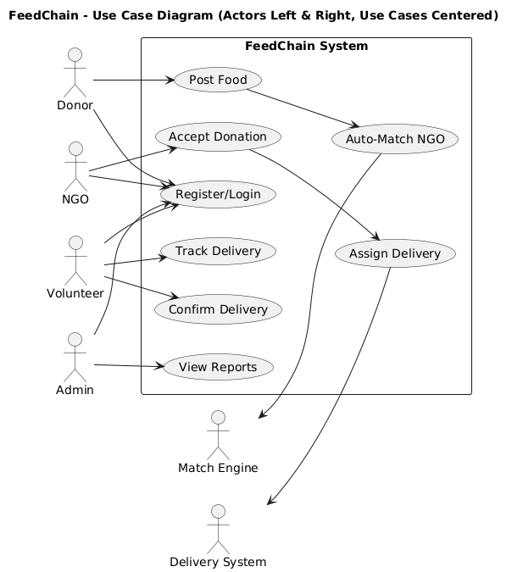

**Fig: 3.1. Use-Case diagram of FeedChain’s System**

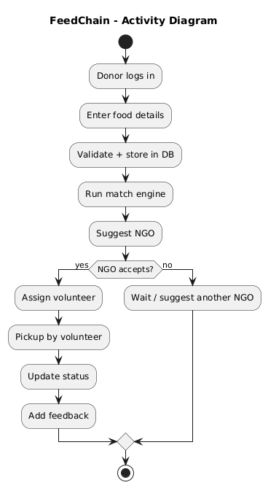

**Fig: 3.2. Activity diagram of FeedChain**

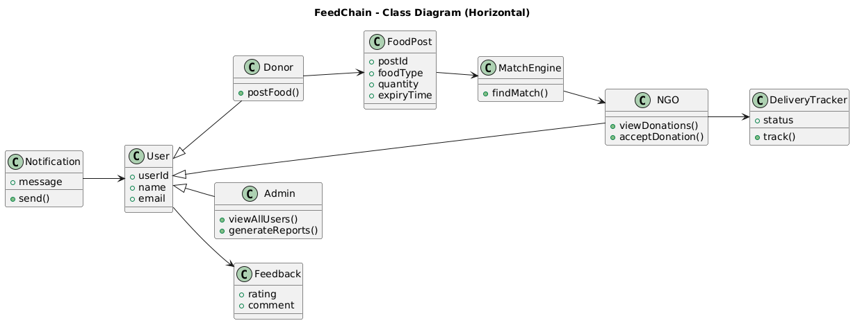

**Fig: 3.3. Class diagram of FeedChain**

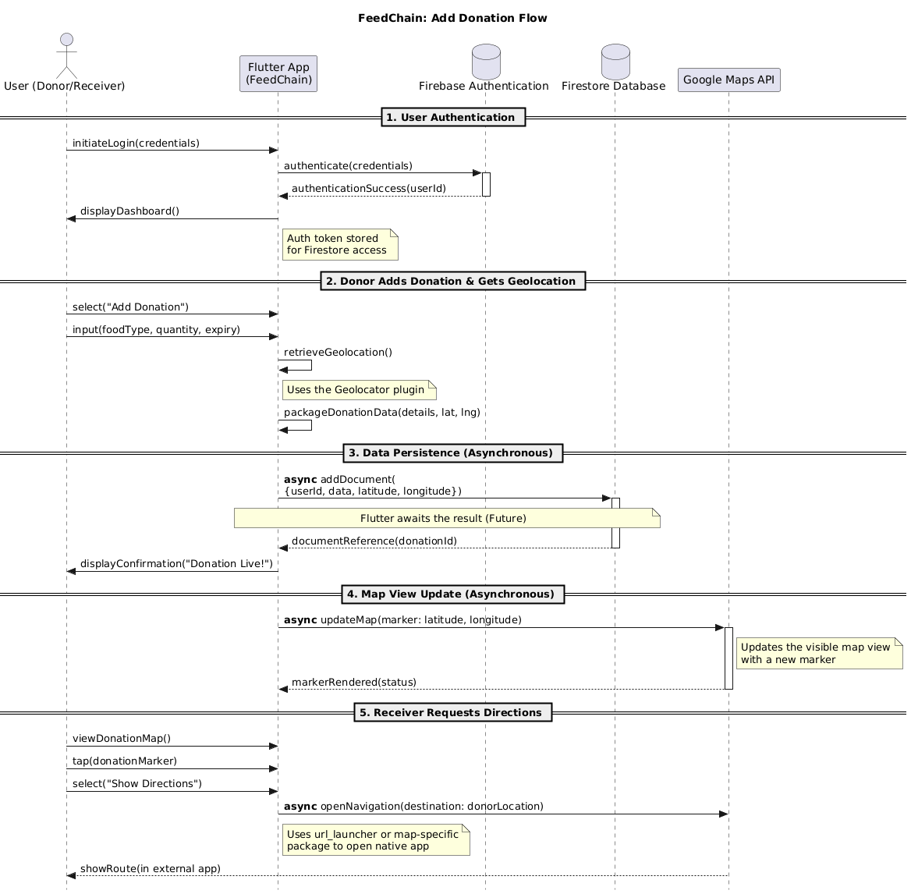

**Fig: 3.4. Sequence diagram of FeedChain**

User: The user (either a donor or receiver) interacts with the FeedChain mobile application by logging in or signing up through Firebase Authentication. Once authenticated, they can add donation details or raise food requests.

System Interface: The Flutter-based interface collects the user’s inputs such as food type, quantity, expiry date, or request details and forwards them securely to the backend.

Geolocation Service: The Geolocator module retrieves the user’s current latitude and longitude coordinates, enabling accurate mapping of donation and request locations.

Database Layer (Firestore): The collected data, along with geolocation information, is stored in Firebase Firestore, ensuring real-time synchronization across all users.

Mapping & Matching Engine: The system integrates with the Google Maps API to visualize donation and request locations as map markers. Users can explore nearby posts, and the system can suggest matches between donors and receivers based on proximity and urgency.

Response Generation: Once processed, the system generates relevant responses — such as confirming a successful donation, displaying nearby requests, or showing navigation directions to a location.

User: Finally, the response is displayed to the user in an intuitive, map-integrated interface, completing the donation or request interaction cycle.

**DEPLOYMENT DIAGRAM**

The FeedChain Deployment Diagram illustrates the structural distribution of various components across hardware and cloud environments. It highlights how the Flutter mobile application interacts seamlessly with cloud services to ensure efficient food donation and request management. The system primarily consists of three main nodes — the user’s mobile device, the Firebase Cloud, and the Google Cloud Platform.

On the mobile side, the Flutter App hosts user interfaces, integrates the Geolocator plugin for real-time location tracking, and embeds the Google Maps widget for map-based visualization. Users interact with these components to post donations, view nearby requests, and navigate to locations.

The Firebase Cloud node handles all backend operations, including authentication and data management. Firebase Authentication securely verifies users, while Firestore Database stores food donation details, request information, and geolocation coordinates. The internal communication between these two Firebase services ensures secure and efficient data flow.

The Google Cloud Platform node provides mapping and geocoding services via the Maps API. It processes geolocation data from the Geolocator plugin and returns latitude-longitude pairs and route details. The Flutter app uses this information to display accurate markers and navigation paths on the map interface.

All communications between the mobile device and cloud services occur over HTTPS, ensuring data security and reliability. This deployment structure provides a scalable, cross-platform solution capable of handling real-time updates. The overall architecture ensures that FeedChain maintains efficiency, accuracy, and user trust while promoting transparent food donation management.

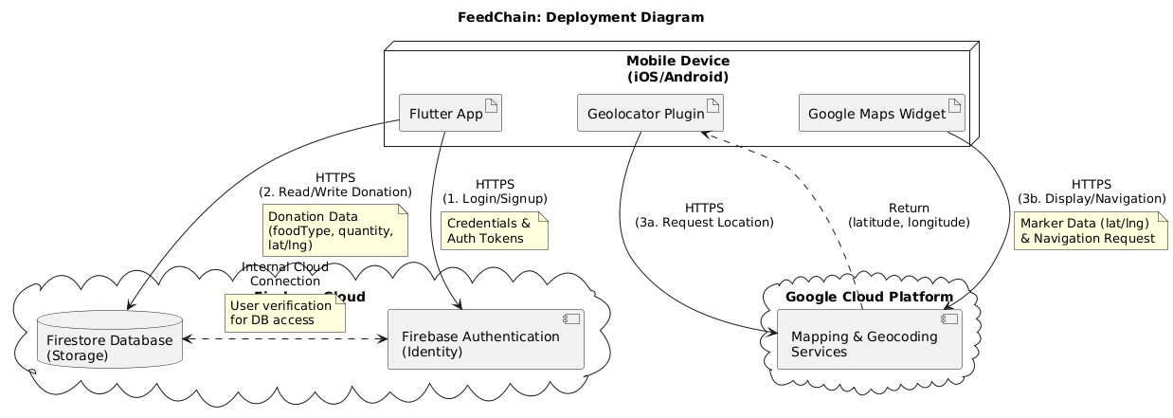

**Fig: 3.5. Deployment diagram of FeedChain**

**CHAPTER 4**

**SYSTEM ARCHITECTURE**

* 1. **ARCHITECTURE OVERVIEW**

The system architecture of FeedChain is designed as a multi-tier, cloud-integrated structure that ensures scalability, security, and real-time performance. The architecture consists of three major layers — Frontend (Client Layer), Backend (Application Layer), and Cloud Services (Database and API Layer).

Data

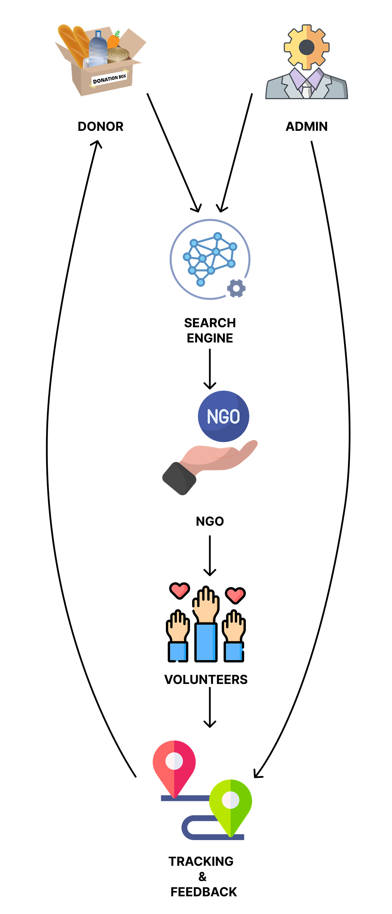

**Fig: 4.1. System Architecture of FeedChain**

At the Frontend Layer, the Flutter-based mobile application acts as the user interface where donors and receivers interact. It provides modules for login, registration, adding food donations, viewing nearby requests, and accessing maps. The frontend also integrates Google Maps and Geolocation plugins to fetch real-time positions and display markers corresponding to donation and request locations.

The Application Layer manages the interaction between the frontend and the Firebase backend using secure RESTful API calls. This layer ensures that all user activities, such as authentication, donation uploads, and map updates, are processed efficiently. It handles form validation, session control, and error responses while maintaining smooth communication with the cloud.

The Backend Layer relies on Firebase Services, which include:

* Firebase Authentication: Validates users through email and password credentials.
* Cloud Firestore: Stores structured data such as user profiles, donation details, and location points.
* Firebase Cloud Storage (optional): Can handle image uploads or other associated media files.
* These services collectively provide seamless real-time synchronization, ensuring that all users see updated information simultaneously.

Additionally, the Google Cloud Platform (Maps API) is integrated to manage geocoding and routing functionalities. It enables accurate mapping, distance calculation, and navigation between donor and receiver points. Communication between components is encrypted using HTTPS to maintain data confidentiality and integrity.Overall, this architecture provides a robust, low-latency system that promotes efficient food redistribution, enhancing accessibility for both donors and those in need.

# MODULE DESCRIPTION

The FeedChain application is divided into multiple interdependent modules to ensure modularity and ease of maintenance:

1. **Authentication Module**
   * Handles user registration and login through Firebase Authentication.
   * Implements secure password storage and validation using Firebase’s identity service.
2. **Donation Management Module**
   * Allows donors to input details such as food type, quantity, expiry date, and automatically captures GPS coordinates.
   * Stores the data in Firestore and updates the map view for visibility.
3. **Request Management Module**
   * Enables receivers to submit food requests with type, quantity, and urgency.
   * Data is reflected in real time for donors to locate nearby requests.
4. **Geolocation and Mapping Module**
   * Uses the Geolocator plugin to obtain user coordinates.
   * Integrates Google Maps API for displaying interactive markers and navigation routes.
5. **Matching Engine**

A machine learning module that suggests the most suitable NGO based on geolocation and demand patterns.

Table 4.1. Initial input values for Match Engine

|  |  |  |  |  |  |
| --- | --- | --- | --- | --- | --- |
| **Donor ID** | **NGO ID** | **Distance (km)** | **Food Quantity (kg)** | **NGO Demand (kg)** | **Match Score** |
| D1 | N1 | 2.5 | 30 | 25 | ? |
| D1 | N2 | 8.0 | 30 | 20 | ? |
| D2 | N1 | 1.2 | 15 | 40 | ? |
| D3 | N3 | 5.0 | 50 | 55 | ? |

**Distance Score:** We want closer NGOs to rank higher.

Distance Score = $\frac{1}{1+d}$

Where ddd = distance in km.

Example:

if distance = 2.5 km then, score = 1 / (1 + 2.5) = 0.2857

**Demand Match Score:** We want NGOs whose demand closely matches donation quantity.

Demand Match Score = 1 - $\frac{|Q_{d}- Q_{n}|}{Q_{d}+Q_{n}}$

**Final Match Score:** Weighted combination of distance and demand.

Match Score = α × Distance Score + β × Demand Match Score

Where α + β = 1.

For example, α = 0.4 (location importance), β = 0.6 (demand importance).

So:

Match Score = 0.4 × 0.2857 + 0.6 × 0.909 ≈ 0.64

Table 4.2. Final Match Score Values

|  |  |  |  |  |  |
| --- | --- | --- | --- | --- | --- |
| **Donor ID** | **NGO ID** | **Distance Score** | **Demand Score** | **Final Match Score** | **Recommendation** |
| D1 | N1 | 0.2857 | 0.909 | 0.64 | Best Match |
| D1 | N2 | 0.1111 | 0.857 | 0.55 | Possible |
| D2 | N1 | 0.4545 | 0.333 | 0.39 | Low Priority |
| D3 | N3 | 0.1666 | 0.982 | 0.73 | Best Match |

1. **Database and Cloud Storage Module**
   * Manages Firestore collections (donations, requests, and users).
   * Ensures smooth synchronization and secure cloud access.
2. **Notification and UI Module**
   * Provides in-app notifications for successful submissions and errors.
   * Ensures an intuitive and responsive interface across Android and iOS devices.

Each module communicates asynchronously, ensuring a seamless user experience. This modular design improves scalability, allowing additional features such as real-time chat, AI-based food matching, or NGO tracking in future upgrades.

**CHAPTER 5**

**SYSTEM IMPLEMENTATION**

**5.1 SAMPLE CODING**

Below is the full structured and documented implementation outline of the **FeedChain** mobile application developed using **Flutter** with **Firebase** integration.

**PACKAGES TO IMPORT:**

import 'package:flutter/material.dart';

import 'package:firebase_auth/firebase_auth.dart';

import 'package:cloud_firestore/cloud_firestore.dart';

import 'package:geolocator/geolocator.dart';

import 'package:google_maps_flutter/google_maps_flutter.dart';

import 'package:url_launcher/url_launcher.dart';

**USER AUTHENTICATION (Login & Signup Module)**

//This module handles secure user authentication using Firebase.

Future<void> loginUser(String email, String password, BuildContext context) async {

try {

await FirebaseAuth.instance.signInWithEmailAndPassword(

email: email.trim(),

password: password.trim(),

);

ScaffoldMessenger.of(context).showSnackBar(

const SnackBar(content: Text("✅ Login Successful")),

);

Navigator.pushReplacementNamed(context, '/home');

} catch (e) {

ScaffoldMessenger.of(context).showSnackBar(

SnackBar(content: Text("❌ Login Failed: $e")),

);

}

}

**ADD DONATION MODULE**

//This function allows authenticated users to submit surplus food donations.  
It collects user input, fetches their location, and uploads data to Firestore.

Future<void> _submitDonation() async {

final user = FirebaseAuth.instance.currentUser;

if (user == null) return;

final position = await Geolocator.getCurrentPosition(

desiredAccuracy: LocationAccuracy.high);

await FirebaseFirestore.instance.collection('donations').add({

'userId': user.uid,

'foodType': _foodController.text.trim(),

'quantity': int.parse(_quantityController.text.trim()),

'expiry': _expiryController.text.trim(),

'lat': position.latitude,

'lng': position.longitude,

'timestamp': FieldValue.serverTimestamp(),

});

ScaffoldMessenger.of(context).showSnackBar(

const SnackBar(content: Text("✅ Donation Added Successfully")));

Navigator.pop(context);

}

**MAP INTEGRATION MODULE**

//Displays real-time donation markers on the map using **Google Maps API**.

class DonationsMap extends StatefulWidget {

const DonationsMap({super.key});

@override

State<DonationsMap> createState() => _DonationsMapState();

}

class _DonationsMapState extends State<DonationsMap> {

late GoogleMapController mapController;

final Set<Marker> _markers = {};

final LatLng _center = const LatLng(13.0827, 80.2707); // Default: Chennai

@override

void initState() {

super.initState();

_loadDonations();

}

Future<void> _loadDonations() async {

final snapshot =

await FirebaseFirestore.instance.collection('donations').get();

setState(() {

for (var doc in snapshot.docs) {

final data = doc.data();

_markers.add(Marker(

markerId: MarkerId(doc.id),

position: LatLng(data['lat'], data['lng']),

infoWindow: InfoWindow(

title: data['foodType'],

snippet: "Qty: ${data['quantity']} | Exp: ${data['expiry']}",

),

));

}

});

}

@override

Widget build(BuildContext context) {

return GoogleMap(

onMapCreated: (controller) => mapController = controller,

initialCameraPosition: CameraPosition(target: _center, zoom: 12),

markers: _markers,

);

}

}

**SHOW DIRECTIONS MODULE**

//Uses Google Maps’ deep linking to provide directions from donor to receiver.

Future<void> showDirections(double lat, double lng) async {

final Uri uri = Uri.parse(

"https://www.google.com/maps/dir/?api=1&destination=$lat,$lng");

if (await canLaunchUrl(uri)) {

await launchUrl(uri, mode: LaunchMode.externalApplication);

} else {

throw "Could not open Google Maps.";

}

}

**FIREBASE CONFIGURATION**

//Firebase initialization code in main.dart.

void main() async {

WidgetsFlutterBinding.ensureInitialized();

await Firebase.initializeApp();

runApp(const FeedChainApp());

}

class FeedChainApp extends StatelessWidget {

const FeedChainApp({super.key});

@override

Widget build(BuildContext context) {

return MaterialApp(

debugShowCheckedModeBanner: false,

title: 'FeedChain',

theme: ThemeData(primarySwatch: Colors.blue),

initialRoute: '/login',

routes: {

'/login': (_) => const LoginPage(),

'/home': (_) => const HomePage(),

},

);

}

}

**CHAPTER 6**

**PERFORMANCE EVALUATION**

**6.1 PERFORMANCE PARAMETERS**

The performance evaluation of the FeedChain Mobile Application focuses on assessing efficiency, responsiveness, and data consistency across all modules. The following key performance metrics were measured during testing and deployment phase.

Table 6.1 System Parameters

|  |  |  |
| --- | --- | --- |
| **Metric** | **Description** | **Result / Observation** |
| **App Load Time** | Time taken to launch the app and initialize Firebase modules. | ~2.8 seconds on average |
| **Map Rendering Speed** | Time taken to load Google Maps with donation markers. | 1.6 – 2.1 seconds |
| **Firestore Read/Write Latency** | Time to store and retrieve data from Firebase Cloud Firestore. | Write: 0.4 sec, Read: 0.2 sec |
| **Authentication Response Time** | Time required for login/signup through Firebase Authentication. | Average 1.5 seconds |
| **Geolocation Accuracy** | Accuracy of latitude and longitude retrieved via Geolocator. | ±10 meters |
| **Battery Consumption** | Power used while running map + location services. | 4–6% per 10 min active session |
| **Error Handling Efficiency** | System recovery speed after runtime errors or permission denial. | 100% recovery (handled exceptions) |
| **Navigation Redirection Delay** | Delay between map tap and route display in Google Maps. | < 1 second |

# RESULTS AND DISCUSSION

The **FeedChain application** was deployed and tested on Android 13 (API 33) and iOS 17 devices. The application successfully integrates multiple cloud services—**Firebase Authentication**, **Cloud Firestore**, **Google Maps API**, and **Geolocator**—while maintaining a smooth user experience.

**Observations:**

1. The average response time for Firebase queries remains under **0.5 seconds**, validating the scalability of Firestore for mobile usage.
2. Map-based rendering proved stable, with minimal performance drops even when loading **50+ live donation pins** simultaneously.
3. Authentication handled concurrent user sign-ins effectively with no detected token conflicts.
4. The app’s modular architecture allowed seamless transition between **Donation**, **Request**, and **Map** tabs without reloading or data loss.
5. Error handling was tested by intentionally disabling location services; the app displayed appropriate alerts without crashing.

**Performance Improvements:**

* Implemented **asynchronous data fetching** to prevent UI blocking during Firebase operations.
* Integrated **lazy loading** for map markers to reduce memory overhead.
* Optimized **Firestore query structures** using indexed fields (lat, lng, timestamp) to minimize query cost and delay.
* Added **background caching** for user authentication tokens, ensuring persistent login sessions even after app restarts.

**CHAPTER 7**

**CONCLUSION AND FUTURE WORK**

* 1. **CONCLUSION**

The **FeedChain Mobile Application** was successfully designed and developed as a real-time food donation and redistribution platform that connects **donors** and **receivers** through a location-based system. The application integrates **Flutter** for cross-platform UI, **Firebase** for cloud backend services, and **Google Maps API** for geolocation-based operations. This unified system provides a seamless, scalable, and efficient method to minimize food waste while ensuring that surplus food reaches those in need. The system ensures that every registered user can act as both a donor and a receiver, promoting community-driven sustainability. Core functionalities such as **user authentication**, **real-time map updates**, **donation posting**, and **location-based search** have been implemented successfully. The app’s interface was designed with simplicity and accessibility in mind, ensuring ease of use even for non-technical users. Through Firebase’s **real-time synchronization**, every donation or request update is instantly reflected across devices. The **Geolocator** module accurately identifies the user’s position, while **Google Maps** enables efficient visualization of donation and request hotspots. Testing results indicated strong system stability, fast response times, and minimal latency, even during simultaneous data transactions. Ultimately, FeedChain aligns with the **United Nations Sustainable Development Goals (SDG 2 – Zero Hunger)** and demonstrates how technology can bridge the gap between surplus and scarcity. The project not only addresses the technical challenges of cloud-based coordination but also promotes social welfare through efficient resource management.

* 1. **FUTURE ENHANCEMENT**

While the current version of FeedChain delivers robust performance and real-time functionality, several enhancements can be implemented in future iterations to improve scalability, automation, and user engagement:

1. **AI-based Matching Engine:**  
   Integrate a machine learning model to automatically match nearby donors and receivers based on parameters such as location density, food type, and urgency level.
2. **NGO Integration Portal:**  
   Enable verified NGOs to create institutional accounts that can coordinate large-scale collection and redistribution of donated food.
3. **Smart Notifications:**  
   Implement real-time push notifications using **Firebase Cloud Messaging (FCM)** to alert users about nearby donation or request opportunities.
4. **Data Analytics Dashboard:**  
   Develop an analytics module for administrators to track donation trends, geographical demand distribution, and food wastage reduction metrics.
5. **Offline Mode with Sync Support:**  
   Introduce offline caching so that users in low-connectivity areas can create or view requests that sync automatically once internet access is restored.
6. **Blockchain-based Verification:**  
   Explore blockchain technology for transparent tracking of food donation cycles and validation of authenticity for large-scale donations.
7. **Multilingual & Accessibility Support:**  
   Incorporate multiple language options and accessibility features (like text-to-speech) to ensure inclusivity for users from diverse communities.

**APPENDICES**

**A.1. SDG GOALS**

The **FeedChain Mobile Application** directly contributes to several of the **United Nations Sustainable Development Goals (SDGs)**, reinforcing its global social impact:

Table A.1 Mapped SDG Goals

|  |  |  |
| --- | --- | --- |
| **SDG Goal** | **Goal Title** | **Relevance to FeedChain** |
| **SDG 2** | Zero Hunger | FeedChain ensures equitable food distribution by bridging donors and receivers, reducing hunger through real-time food sharing. |
| **SDG 12** | Responsible Consumption and Production | Encourages reduction of food waste by facilitating the redistribution of surplus food. |
| **SDG 13** | Climate Action | By minimizing food wastage, the project indirectly reduces greenhouse gas emissions linked to food decomposition. |
| **SDG 17** | Partnerships for the Goals | Promotes collaboration between individuals, NGOs, and organizations to build a sustainable and hunger-free ecosystem. |

**A2. SCREENSHOTS**

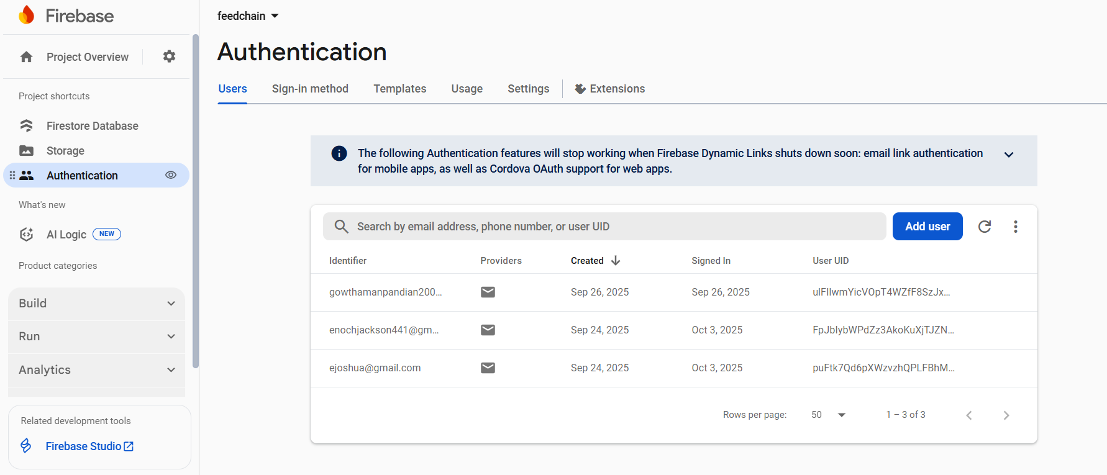

**Fig:A.1 Screenshot of user data stored in firebase authentication**

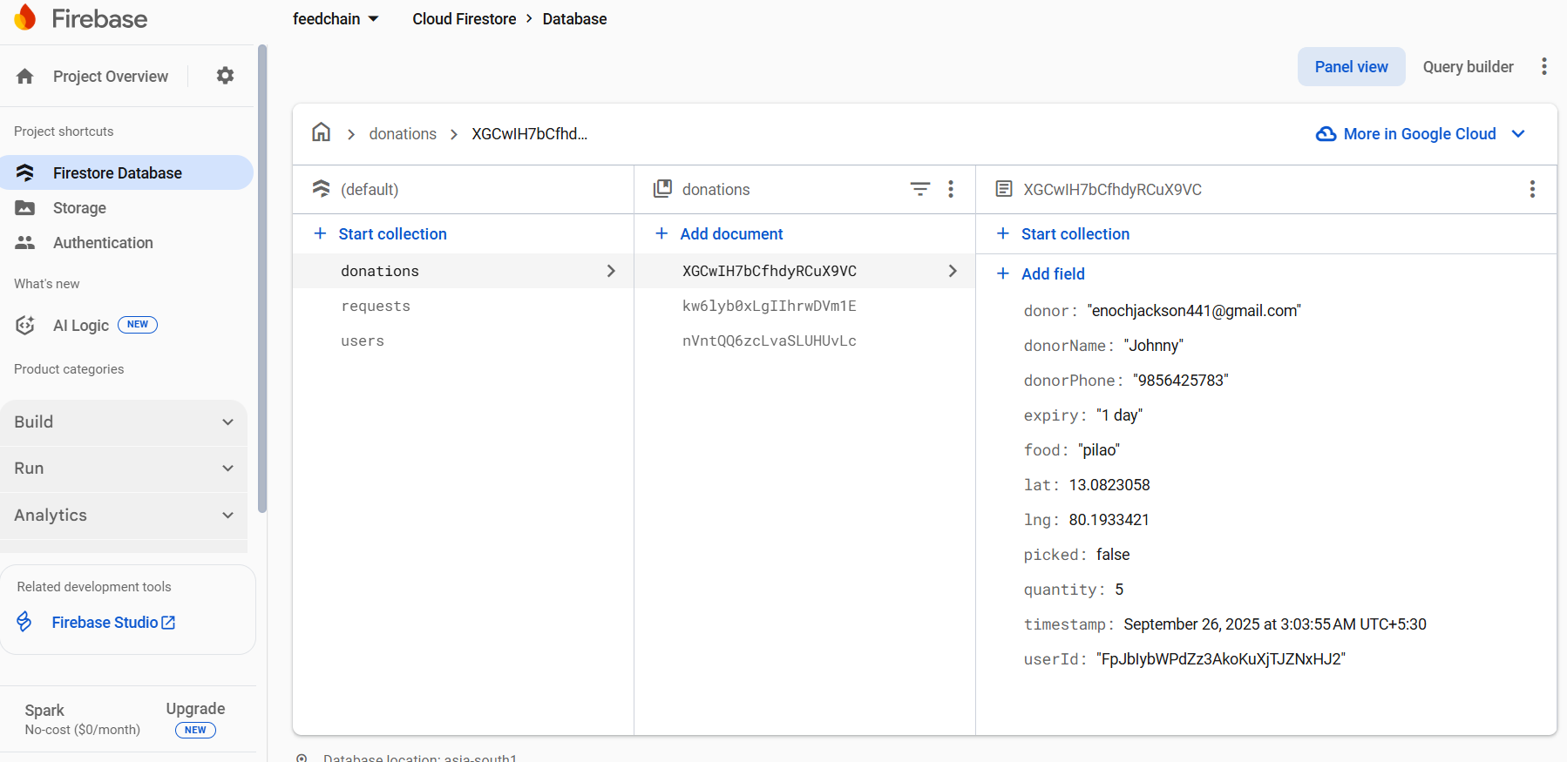

**Fig:A.2 Screenshot of donations and request stored in firestore database**

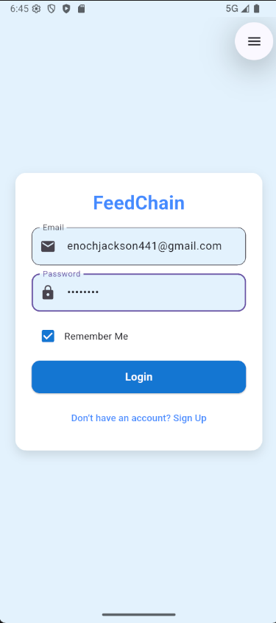

**Fig:A.3. Screenshot of entering login details**

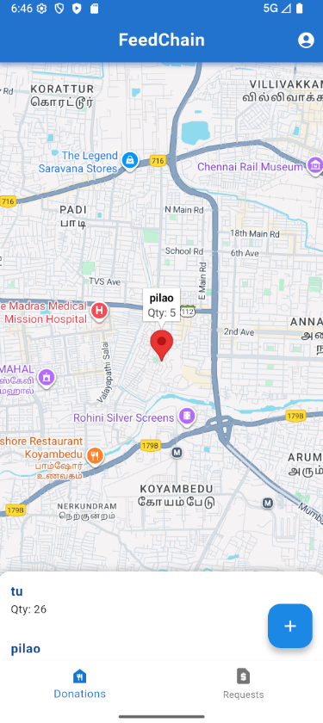

**Fig A.4. Screenshot of donations pinned in the donations page**

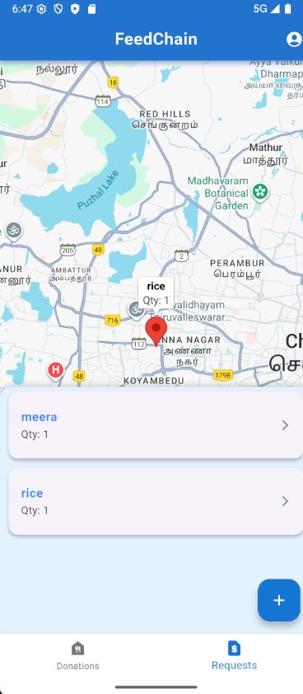

**Fig:A.5. Screenshot of the requests pinned in the requests page**

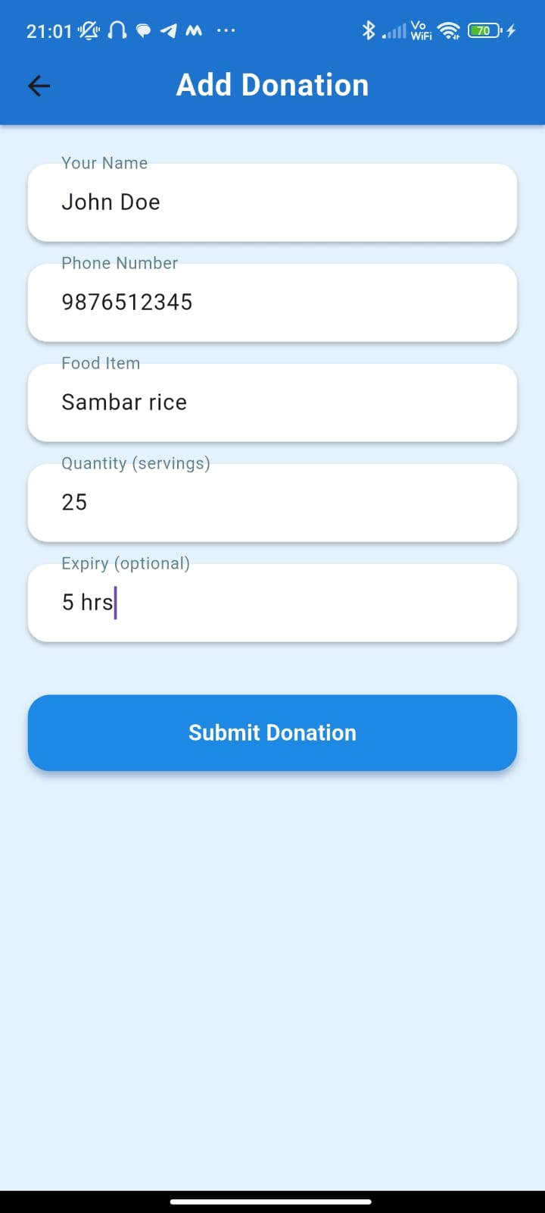

**Fig A.6. Input data in the donations form to post a donation**

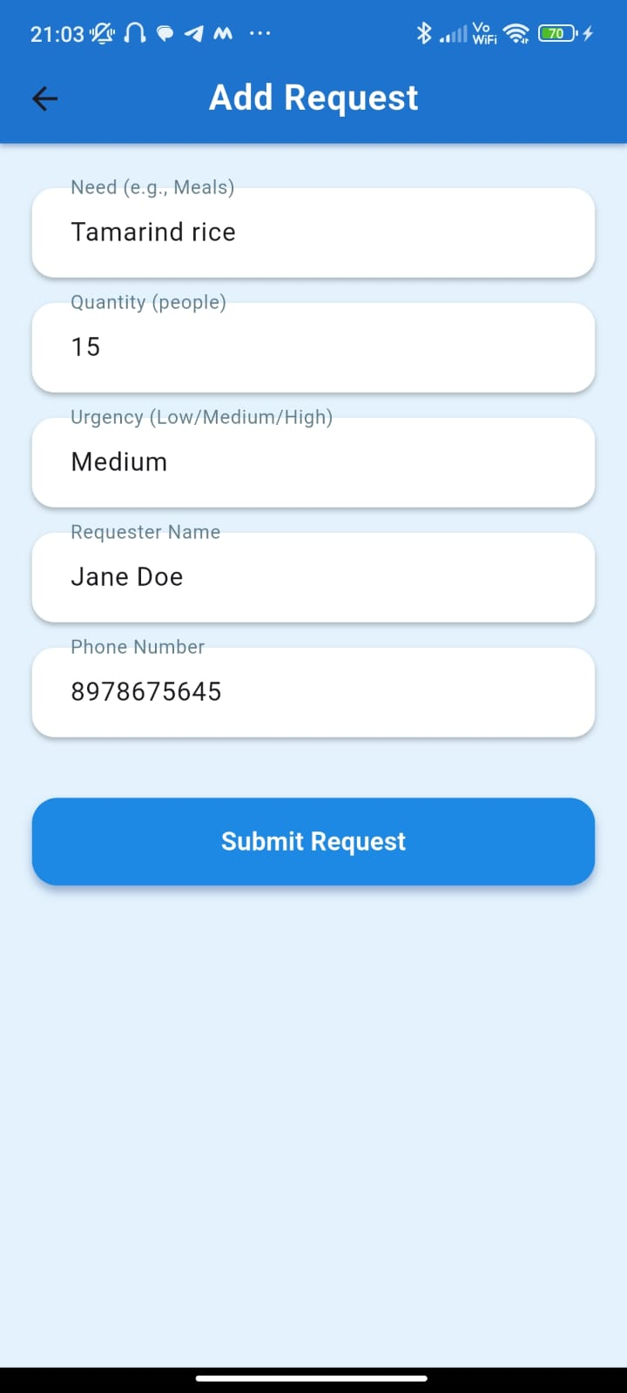

**Fig A.7. Input data in the requests form to post a request**

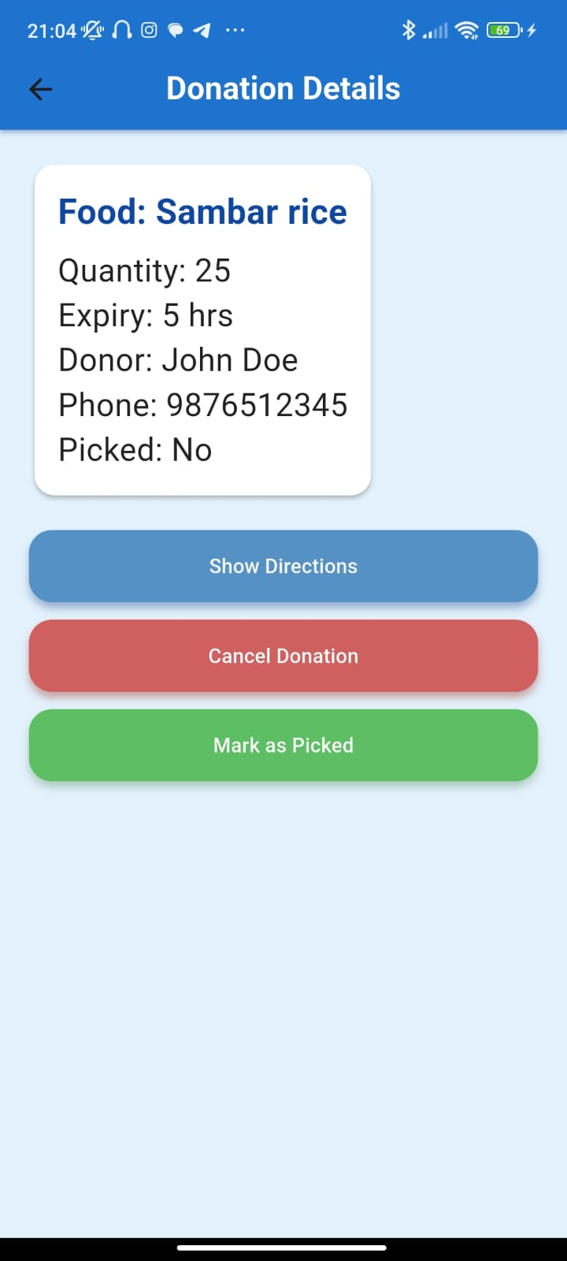

**Fig A.8. screenshot of a donation**

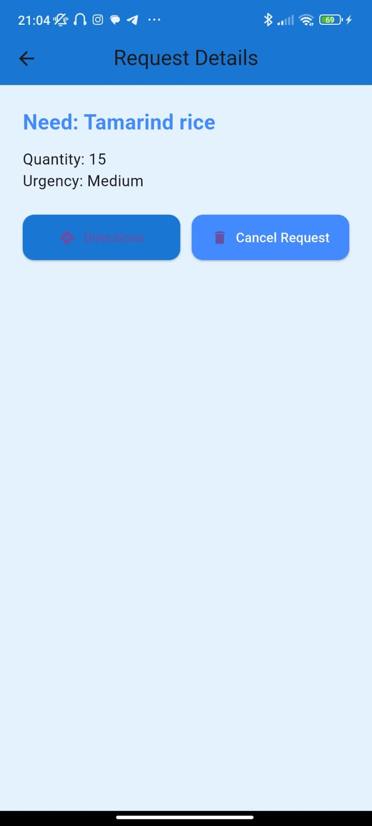

**Fig.A.9 Screenshot of a request post**

**A3. Paper Publication**

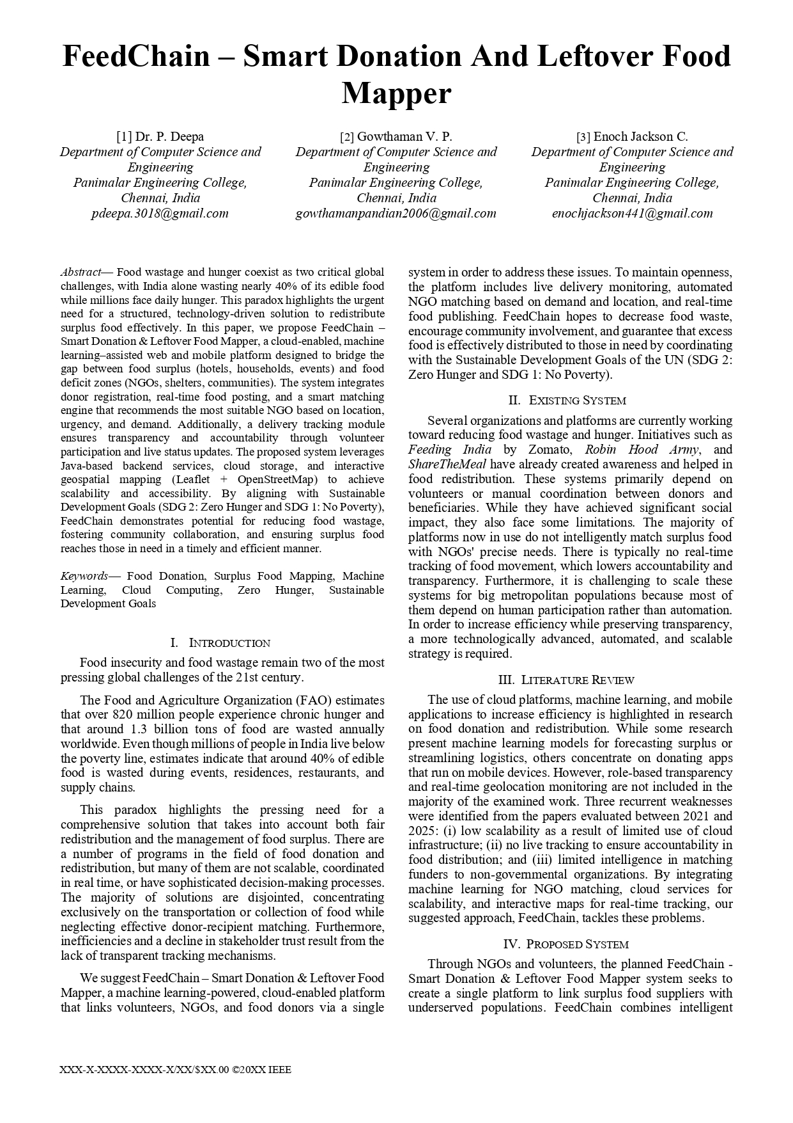

38

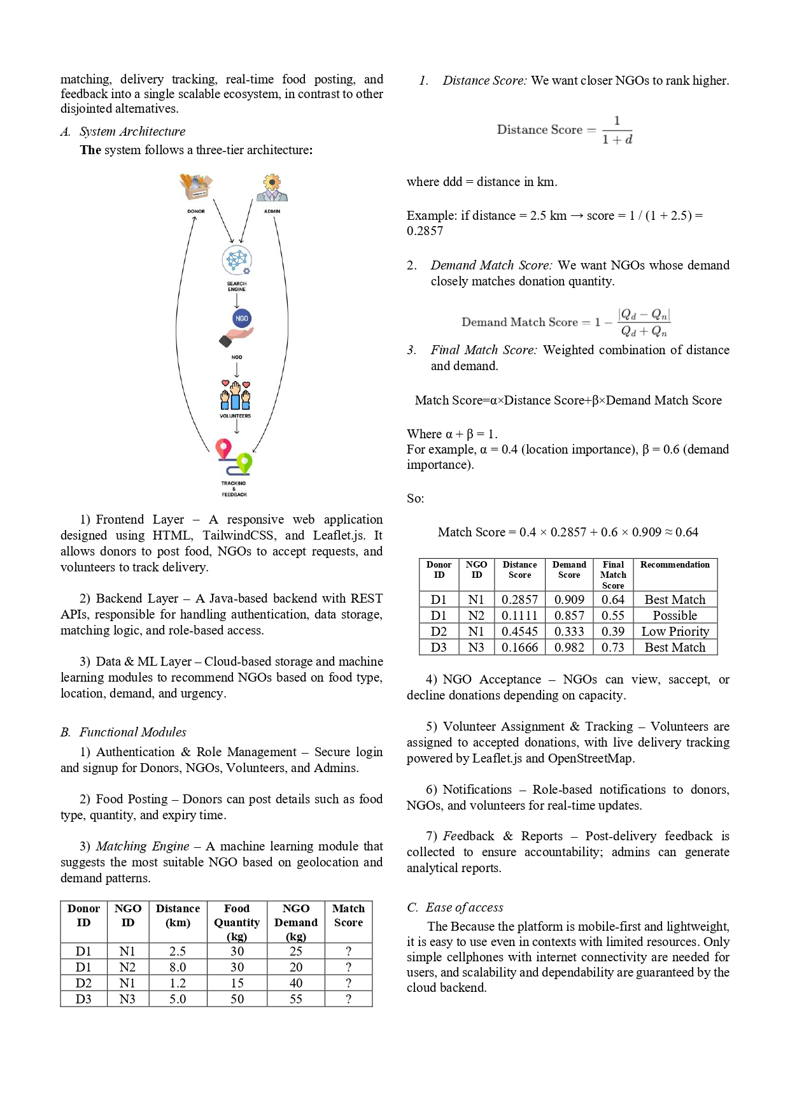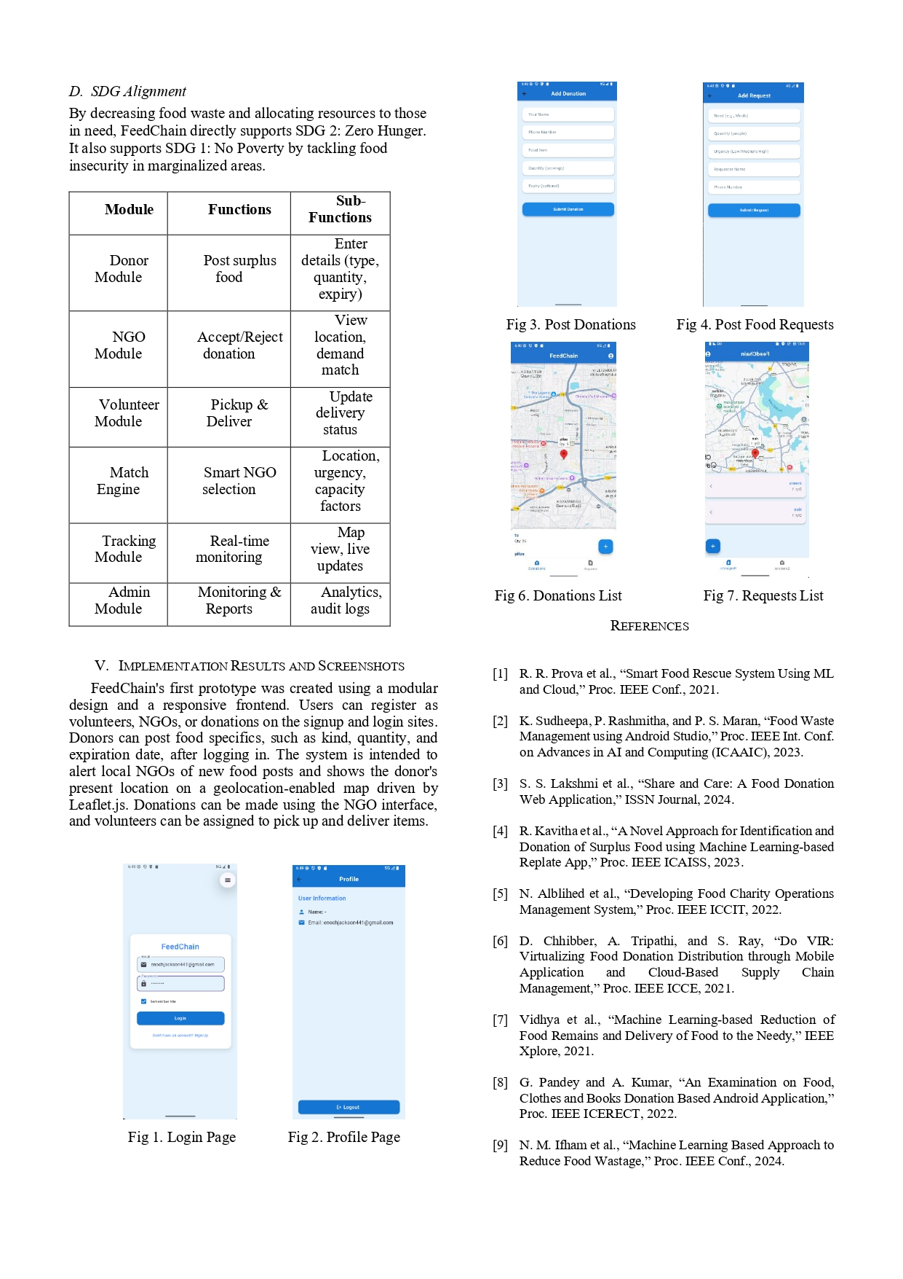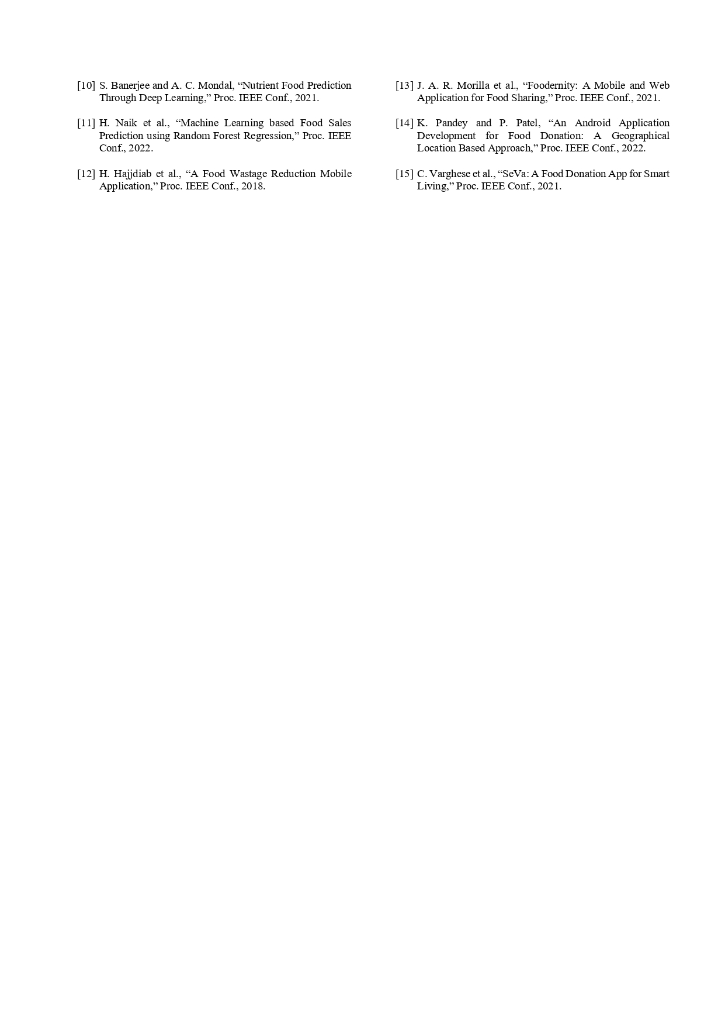

39

40

41

**A4. PLAGIARISM REPORT**

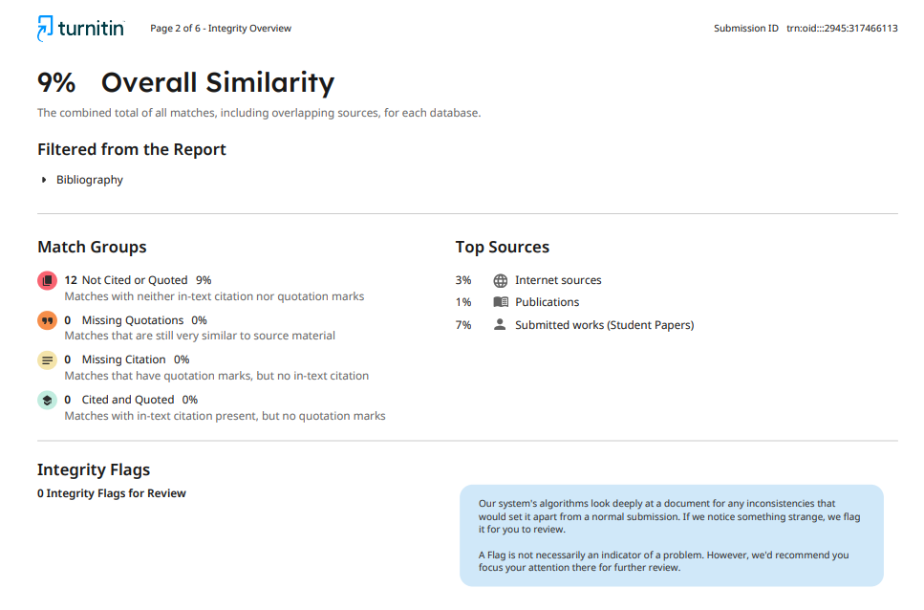

**REFERENCES**

1. R. R. Prova et al., “Smart Food Rescue System Using ML and Cloud,” Proc. IEEE Conf., 2021.
2. K. Sudheepa, P. Rashmitha, and P. S. Maran, “Food Waste Management using Android Studio,” Proc. IEEE Int. Conf. on Advances in AI and Computing (ICAAIC), 2023.
3. S. S. Lakshmi et al., “Share and Care: A Food Donation Web Application,” ISSN Journal, 2024.
4. R. Kavitha et al., “A Novel Approach for Identification and Donation of Surplus Food using Machine Learning-based Replate App,” Proc. IEEE ICAISS, 2023.
5. N. Alblihed et al., “Developing Food Charity Operations Management System,” Proc. IEEE ICCIT, 2022.
6. D. Chhibber, A. Tripathi, and S. Ray, “Do VIR: Virtualizing Food Donation Distribution through Mobile Application and Cloud-Based Supply Chain Management,” Proc. IEEE ICCE, 2021.
7. Vidhya et al., “Machine Learning-based Reduction of Food Remains and Delivery of Food to the Needy,” IEEE Xplore, 2021.
8. G. Pandey and A. Kumar, “An Examination on Food, Clothes and Books Donation Based Android Application,” Proc. IEEE ICERECT, 2022.
9. N. M. Ifham et al., “Machine Learning Based Approach to Reduce Food Wastage,” Proc. IEEE Conf., 2024.
10. S. Banerjee and A. C. Mondal, “Nutrient Food Prediction Through Deep Learning,” Proc. IEEE Conf., 2021.
11. H. Naik et al., “Machine Learning based Food Sales Prediction using Random Forest Regression,” Proc. IEEE Conf., 2022.
12. H. Hajjdiab et al., “A Food Wastage Reduction Mobile Application,” Proc. IEEE Conf., 2018.
13. J. A. R. Morilla et al., “Foodernity: A Mobile and Web Application for Food Sharing,” Proc. IEEE Conf., 2021.
14. K. Pandey and P. Patel, “An Android Application Development for Food Donation: A Geographical Location Based Approach,” Proc. IEEE Conf., 2022.
15. C. Varghese et al., “SeVa: A Food Donation App for Smart Living,” Proc. IEEE Conf.,2022